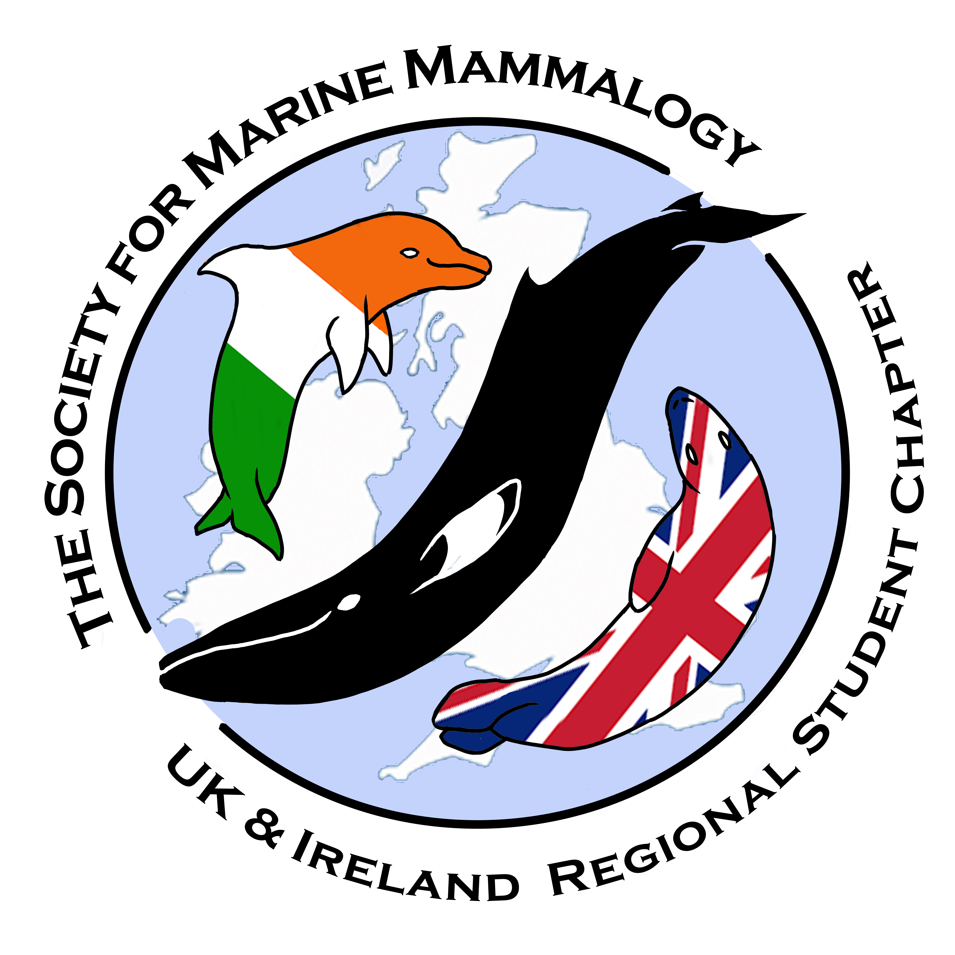
2017 Annual Meeting of the UK & Ireland Regional Student Chapter of the
Society for Marine Mammalogy
Marine Station, Plymouth University,
January 18th – 20th, 2017

REGISTRATION FORM

NAME :
UNIVERSITY:
EMAIL:
DEGREE:
(Undergraduate, Masters, PhD, Non-student)
DIETARY REQUIREMENTS:

Do you wish to apply for a travel grant? (Only for students outside Plymouth)
Yes/No.
An Ice Breaker will be held on the evening of the 18th of January in Plymouth, will you be able to attend?

Yes/No

On the evening of the 19th^{t} of January we go out for dinner in Plymouth, will you be able to attend?

Yes/No

PHOTO-COMPETION INFO

If you want to be in the chance of winning a free conference meal (on Thursday), send us a photo!
We will shortlist the best 10 by the 4th of Jan and you guys can vote for the best one by the 11th. All shortlisted photographs will be used for our website and anything we publish in the form of social media, conference programmes etc.

- There are no rules regarding what species it is, or where the photo was taken.
- Photo must be taken by you, and it must be your property and not the property of an organisation that you were working for when the photo was taken (due to copyright infringement)
- You must have registered for the conference to take part in the competition.

2017 Annual Meeting of the UK & Ireland Regional Student Chapter of the
Society for Marine Mammalogy
Marine Station, Plymouth University,
January 18th – 20th, 2017

REGISTRATION FORM

PRESENTATIONS:

It is not obligatory to give a presentation. However, for those wishing to present, we encourage students further along in their projects to do a 15 minute talk. Best 15 minute talk of the conference (judged by attendees) will WIN A FREE STATISTICS COURSE, courtesy of PR Statistics (not travel or accommodation).

Please delete as appropriate.

- Poster
- 5 Minute Speed Talk
- 15 Minute Talk (12 minute presentation with 3 minutes for questions)

TITLE:

AUTHORS:

ABSTRACT (max. 250 words):

